Use Case Diagram

Submitted By

Minnu Raj

Roll No: 24

S5 MCA Reg

Amal Jyothi Collage

Of Eng, Kanjirappally.

Use case diagram of admin and user

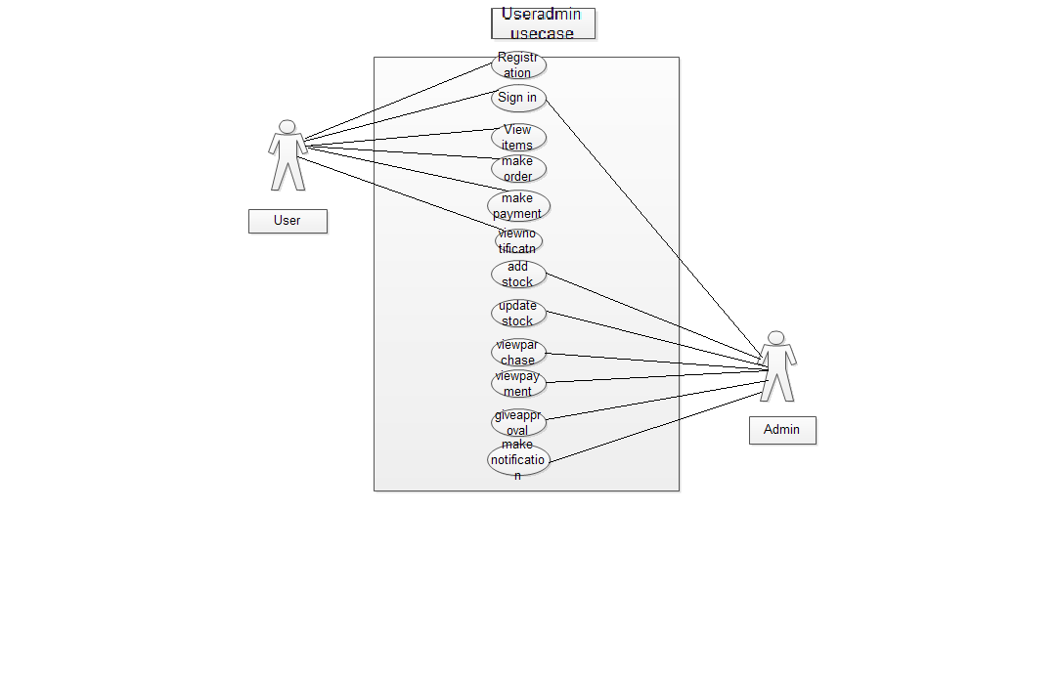

Use case diagram of Shop

